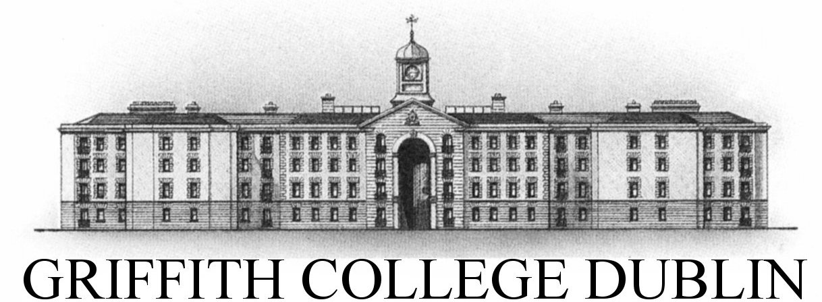

**Assignment Cover Sheet**

|  |  |  |  |  |  |  |
| --- | --- | --- | --- | --- | --- | --- |
| **Student name:** | **Sarah Narayamy Tavares Silva** | | | | | |
| **Student number:** | **2960992** | | |  | | |
| **Faculty:** | **Computing Science** | | |  | | |
| **Course:** | **Computing Science** | | | **Stage/year:** | **3** | |
| **Subject:** | **Networks and Data Communications** | | | | | |
| **Study Mode:** | Full time | **X** |  | Part-time |  |  |
| **Lecturer Name:** | **Brendan Fogarty** | | | | | |
| **Assignment Title:** | **Research Assignment** | | | | | |
| **No. of pages:** |  | | |  | | |
| **Disk included?** | Yes |  |  | No | **X** |  |
| **Additional Information:** | (ie. number of pieces submitted, size of assignment, A2, A3 etc) | | | | | |
|  | | | | | |
|  | | | | | |
| **Date due:** |  | | |  | | |
| **Date submitted:** |  | | |  | | |
|  | | | | | | |
| **Plagiarism disclaimer:**  *I understand that plagiarism is a serious offence and have read and understood the college policy on plagiarism. I also understand that I may receive a mark of zero if I have not identified and properly attributed sources which have been used, referred to, or have in any way influenced the preparation of this assignment, or if I have knowingly allowed others to plagiarise my work in this way.*  *I hereby certify that this assignment is my own work, based on my personal study and/or research, and that I have acknowledged all material and sources used in its preparation. I also certify that the assignment has not previously been submitted for assessment and that I have not copied in part or whole or otherwise plagiarised the work of anyone else, including other students.*  **Signed: Sarah Narayamy Tavares Silva Date: ______________________** | | | | | | |

## **Please note:** Students **MUST** retain a hard / soft copy of **ALL** assignments as well as a receipt issued and signed by a member of Faculty as proof of submission.

TABLE OF CONTENTS

1 INTRODUCTION 2

2 AT&T NETWORK OUTAGE – JANUARY 15TH 1990 3

3 ARIANE 5 FLIGHT 501 – JUNE 4TH 1996 6

4 NOVEMBER 2000 – NATIONAL CANCER INSTITUTE, PANAMA CITY 8

5 CONCLUSION 11

REFERENCES 12

# 1 INTRODUCTION

According to Collins dictionary, Network stands for a system of things which are connected and which operate together. In the computer world, a computer network is a number of computers that connect with each other in order to promote communication of data between users.

There are several ways to structure a network, such as Local Area Network (LAN), Metropolitan Area Network (MAN), Wide Area Network (WAN), Personal Area Network (PAN), Storage Area Network (SAN), Enterprise Private Network (EPN) and Virtual Private Network (VPN), each one of them with its particular aspects. Usually, these network perform with the use of cables such as CAT5 and CAT5e, but it is possible to create a network without cables, thus Wireless like is the case of WANs among others.

# 2 HISTORY OF WIRELESS NETWORK

It all started with in the preindustrial age when the line-of-sight distances were used using smoke signals, torch signalling, flashing mirrors, signal flares, and semaphore flags.

In 1838 Samuel Morse invented the telegraph network that replaced the observation stations which were built in top of hills and along roads to spread the messages over large distances following by the telephone. Marconi demonstrated the first radio transmission through a 18 miles distance in 1895.

Radio transmissions evolved throughout the years improving the quality, the power, size, price, etc. Another aspect that improved within radio systems is the way information is transmitted. In early times, radio systems transmitted only Analog signals, but nowadays, radio systems transmit digital signals which are composed of binary bits.

Ethernet technology started in the 1970s steering away the attention on radio-based networking.

# 3 ARIANE 5 FLIGHT 501 – JUNE 4TH 1996

# 4 NOVEMBER 2000 – NATIONAL CANCER INSTITUTE, PANAMA CITY

# 5 CONCLUSION

# REFERENCES